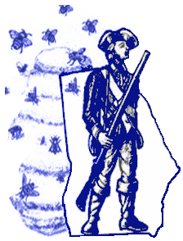

Revolutionary Days
Heroes of the Hornet's Nest Ceremony
Elijah Clark State Park
2959 McCormick Hwy. or
7 miles N.E. on Hwy. 378
Lincolnton, GA
Friday, February 07, 2020
1:30 PM

Wreath Registration

Name of Wreath Presenter___________________________

Organization ______________________________________

Position _______________________________________

Presenter’s e-mail address ____________________________

Send registration form by February 1, 2020, to:

Charlie Newcomer—email: canewcomer@att.net or by regular
mail to 1601 Spartan Lane, Athens, GA. 30606-5327.
Telephone: 706-543-3977

