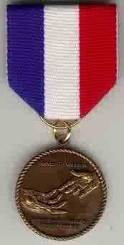 | Service to Veterans Medal

1. This medal will only be awarded to SAR members.
2. This medal will be awarded when a Compatriot has contributed 5,000 Stark points. (These points can be a combination of time given, clothing and/or money donated, or other items based on the USS Stark Award score sheet)
3. Each individual is responsible for recording his personal point accumulation.
4. The chapter Veterans Committee Chairman must verify these points.
5. Point will be retroactive for previous Veterans activities, if points awarded are duly documented.
6. For multiples of 3,000 point a bronze oak leaf cluster will be awarded.
7. After 5 bronze oak leaf clusters have been presented, a silver oak leaf cluster will be presented to replace the 5 previous bronze clusters.
8. A certificate of accomplishment will accompany the medal and each cluster.
9. The chapter or state may present this award
10. The cost of the award will be paid by the awarding organization.

