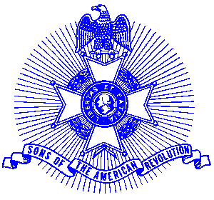Example 1 Bronze/ Silver Good Citizenship Award

For Immediate Release

Local Resident Wins Award

Skip Gray of Alpharetta was recently were presented with a Bronze (Silver) Good Citizenship Medal for his participation in programs for outstanding service to the Sons of the American Revolution.

The medal is bronze (silver) Skip received the Bronze Good Citizenship Medal that recognizes persons whose achievements are noteworthy for SAR activities. The medal is struck on a circular planchet and on the obverse is depicted a Minuteman holding a musket, with a plow, Liberty Bell, the year 1776 in the background and is inscribed “Good Citizenship Medal.” The reverse is inscribed, “Our inspiration is in the past, our duty is in the present, our hope is in the future.” A certificate accompanied the presentation.

The Piedmont Chapter serves the communities of the northern suburbs of Atlanta, including Cobb, Forsyth, Cherokee and North Fulton Counties. Activities include a variety of programs to promote the patriotic, educational and historical interests resulting from the American Revolution.

The award winning Piedmont Chapter meets monthly on the third Saturday at 8:00 a.m. for breakfast at the Integrity Bank, 11140 State Bridge Road, and Alpharetta. Men and boys who are interested in documenting their relationship to their American Revolutionary ancestors and in joining an active group with similar interest, are encouraged to contact the Chapter Registrar, Bob Sapp at 770-971-0189 or email 2rasapp@bellsouth.net.

