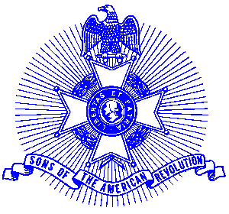Example 2/ Silver Good Citizenship Award

For Immediate Release

Local Resident Wins Award

Tucker Haught of Warner Robins was recently presented with a Silver Good Citizenship Medal for his outstanding participation in programs to the Sons of the American Revolution through his noteworthy service to his community, state, and nation.

The actual medal is struck on a circular planchet and on the obverse is depicted a Minuteman holding a musket, with a plow, Liberty Bell, the year 1776 in the background and is inscribed “Good Citizenship Medal.” The reverse is inscribed, “Our inspiration is in the past, our duty is in the present, our hope is in the future.” A certificate accompanied the presentation.

The Ocumulgee Chapter serves the communities of the suburbs of Forsythe, Macon, Thomaston, and Warner Robins. Activities include a variety of programs to promote the patriotic, educational and historical interests resulting from the American Revolution. Mr. Haught graduated from The University of Georgia with a Bachelor of Business Administration and Georgia College and State University with a Master of Science in Administration. He was recently awarded Eleanor Granum Award for outstanding volunteerism by the American Association of University Women (AAUW) and Governor Sonny Perdue’s Commendation for service through Georgia’s Committee for Employers Support for the Guard and reserve to the State of Georgia.

The Ocmulgee Chapter meets monthly on the first Tuesday at 6:30pm for dinner at The Blue Plate 2323 Ingleside Ave. Macon GA 31204 (478) 478 1600. Men and boys who are interested in documenting their relationship to their American Revolutionary ancestors and in joining an active group with similar interest, are encouraged to contact the Chapter Registrar, Gary Worrell at (478) 929 0975.

