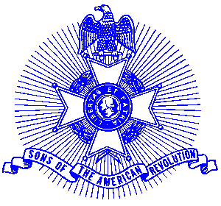Example 2 C.A.R.

FOR IMMEDIATE RELEASE

Local Student Honored

Thomas Jackson of Woodstock, Georgia recently received an Outstanding Citizenship Award from Scott Ray, President of the Piedmont Chapter, Sons of the American Revolution for his participation in several Revolutionary War Soldier Grave Markings by the Piedmont Chapter.

The award consists of a pin, which contains the image of a “Minuteman,” with his musket in hand ready to defend his country. In the background is his plowshare. The pin is encircled with the inscription “Sons of the American Revolution Outstanding Citizenship Award.” The award also comes with a certificate.

Mr. Jackson is a ninth grade student at Crossroads High School in Canton and serves as the President of the Georgia Society, Children of the American Revolution. Mr. Jackson presented wreaths on behalf of the Georgia Society, Children of the American Revolution at each service.

The award winning Piedmont Chapter, Sons of the American Revolution meets monthly on the third Saturday at 8:00 a.m. for breakfast at the Integrity Bank, 11140 State Bridge Road, Alpharetta. Men and boys who are interested in documenting their relationship to their American Revolutionary ancestors and in joining an active group with similar interest, are encouraged to contact the Chapter Registrar, Bob Sapp at 770-971-0189.

The Piedmont Chapter serves the communities of the northern suburbs of Atlanta, including Cobb, Forsyth, Cherokee and North Fulton Counties. Activities include a variety of programs to promote the patriotic, educational and historical interests resulting from the American Revolution.

