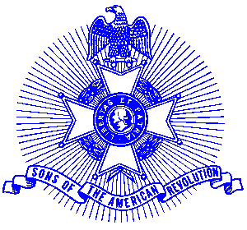Example 3 Chapter Awards

For Immediate Release

Piedmont Chapter Continues to win National Awards

The Piedmont Chapter, Sons of the American Revolution was recently selected as First Runner-up for the President General’s Cup as having the most complete program of activities within the National Society. The Society has membership of over 27,000.

The Chapter was also awarded the President General's Activities Award for the third year in a row. This award, by chapter size, is based on evidence of promoting SAR Activities within the community. A certificate and streamer was presented for the chapter to add to their SAR flag.

Piedmont also was presented with the Liberty Bell Americanism Award for conducting outstanding programs and activities during the course of the year that supported a better understanding in the local community of fundamental American traditions. The President General presented a cash award and certificate to Piedmont Vice President Glynn Acree who represented the chapter at the Congress. This was the second time the chapter has received this award.

Additional awards included, for the sixth consecutive year, the USS Stark Memorial Award as the outstanding chapter of the SAR for their participation in Veterans committee activities.

The Piedmont Chapter serves the communities of the northern suburbs of Atlanta, including Cobb, Forsyth, Cherokee and North Fulton Counties. Activities include a variety of programs to promote the patriotic, educational and historical interests resulting from the American Revolution. Programs include Essay Contests for both High School students and Eagle Scouts, presentation of medals to College and High School ROTC students Poster Contests for Elementary School students, American Revolution presentations to Elementary and Middle School students, presentation of medals to Public Safety officials, Revolutionary War Grave Dedications, Volunteer work with Veterans, presentation of Flag Certificates to deserving organizations and schools, participation in historic battle sites observances and others.

Prospective members are welcome at meetings held on the third Saturday of each month at the Alpharetta Marriott Courtyard. Men and boys who are interested in documenting their relationship to their American Revolutionary ancestors and in joining an active group with similar interest, are encouraged to contact the Chapter Registrar, Bob Sapp at 770-971-0189.

