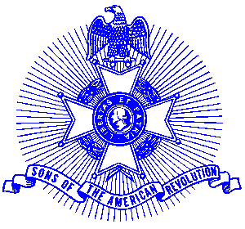Example 20 Meeting Notice

Sons of the American Revolution

The award winning Piedmont Chapter, Sons of the American Revolution meets monthly on the third Saturday at 8:00 a.m. for breakfast at the Integrity Bank, 11140 State Bridge Road, Alpharetta. Men and boys who are interested in documenting their relationship to their American Revolutionary ancestors and in joining an active group with similar interest, are encouraged to contact the Chapter Registrar, Bob Sapp at 770-971-0189.

The Piedmont Chapter serves the communities of the northern suburbs of Atlanta, including Cobb, Forsyth, Cherokee and North Fulton Counties. Activities include a variety of programs to promote the patriotic, educational and historical interests resulting from the American Revolution.

