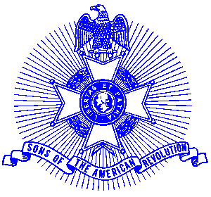Example 6 Constitution Week

For Immediate Release

Constitution Week Proclamation

Alpharetta Mayor Arthur Letchas recently presented a Constitution Week Proclamation to the Piedmont Chapter, Sons of the American Revolution. Constitution Week is celebrated September 17-23 each year and the Piedmont Chapter is promoting a community-wide observance by every household and business during the week. Displaying the United States Flag during Constitution Week is encouraged. The proclamation reads as follows:
A Proclamation

Constitution Week

Whereas: The Constitution of the United States, the guardian of our liberties, is a product of reflection and choice, embodying the principles of limited government in a Republic dedicated to rule by law, not by men and

Whereas: September 17, 2002 marks the two hundred and fifteenth anniversary of the drafting of the Constitution of the United States of America by the Constitution Convention: and

Whereas: It is fitting and proper to accord official recognition to this memorable anniversary, and to the patriotic exercises that will commemorate the occasion, and

Whereas: Public Law 915, guarantees the issue of a proclamation each year by the President of the United States of America designating September 17th through September 23rd as Constitution Week.

NOW THEREFORE: I, Arthur Letchas as Mayor of Alpharetta, proclaim the week of September 17, 2002 through September 23, 2002 as

Constitution Week
And urge all citizens to study the Constitution and to
express gratitude for the privilege of American citizenship
in our Republic, functioning under the superb body of
laws – the Constitution of the United States of America.

Proclaimed this 12th day of September 2002

Arthur G. Letchas, Mayor

