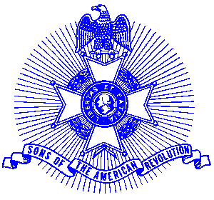Example 9 Fire Safety

For Immediate Release

Roswell Fire Captain Paul Piccirilli Receives Award

Captain Paul Piccirilli of Roswell, Georgia, recently received a Sons of the American Revolution Fire Safety Commendation Award from Piedmont Chapter Public Safety Committee Chairman Tom Thurmond at the Roswell City Hall in a ceremony with Chief Butterworth, and Piedmont President George Thurmond.

Captain Piccirilli was selected in recognition of his accomplishments and outstanding contributions to protecting human life and property by preventing injuries or casualties due to fire. Captain Piccirilli serves as Deputy Chief of the Roswell, Georgia Fire Department.

The medal is struck on a circular planchet and the obverse depicts a fireman’s badge with a flame in the center. Across the top of the outer circumstance are the words "Sons of the American Revolution" and across the bottom are the words " Fire Safety Commendation. " The medal is suspended by a red ribbon drape. A certificate and citation accompanied the presentation.

The purpose of the presentation is to recognize a variety of fire safety and service professionals who have evolved into a highly technical and skilled profession with constant study, development and involving a number of dedicated citizens with a single goal-protect human life and property by preventing injuries or casualties due to fire and chemicals.

The Piedmont Chapter serves the communities of the northern suburbs of Atlanta, including Cobb, Forsyth, Cherokee and North Fulton Counties. Activities include a variety of programs to promote the patriotic, educational and historic interests resulting from the American Revolution.

Prospective members are welcome at meetings held on the third Saturday of each month at the Alpharetta Marriott Courtyard. Men and boys who are interested in documenting their relationship to their American Revolutionary ancestors and in joining an active group with similar interests are encouraged to contact the Chapter Registrar, Bob Sapp at (770) 971-0189.

