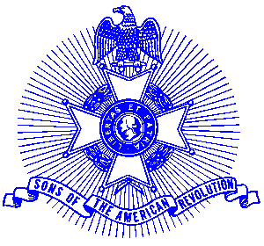Example 10 Flag Certificate

For Immediate Release

Flag Certificate Awarded to Local Business

Jebco Ventures, Inc. recently received a Flag Certificate from the Piedmont Chapter, Sons of the American Revolution commending the business on properly displaying and flying the American Flag. Making the presentation were following the raising of “Old Glory” was (left-right) Scott Ray, President of the Piedmont Chapter, Glynn Acree, Vice President and Jebco Executive Vice President Bill Kolbrener.

The Sons of the American Revolution has a program to locate and identify and present Flag Certificates to schools, organizations and businesses that display the American flag properly. The certificate contains a Betsy Ross flag that became the standard during the American Revolution and the current 50 state Stars & Stripes flag.

The award winning Piedmont Chapter, Sons of the American Revolution meets monthly on the third Saturday at 8:00 a.m. for breakfast at the Integrity Bank, 11140 State Bridge Road, Alpharetta. Men and boys who are interested in documenting their relationship to their American Revolutionary ancestors and in joining an active group with similar interest, are encouraged to contact the Chapter Registrar, Bob Sapp at 770-971-0189.

The Piedmont Chapter serves the communities of the northern suburbs of Atlanta, including Cobb, Forsyth, Cherokee and North Fulton Counties. Activities include a variety of programs to promote the patriotic, educational and historical interests resulting from the American Revolution.

