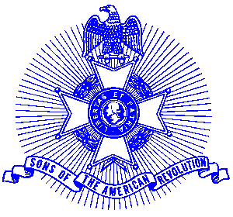Example 11 Flag Day

FOR IMMEDIATE RELEASE

Roswell Mayor Jere Wood recently presented a Flag Day Proclamation to the Piedmont Chapter, Sons of the American Revolution at a meeting of City Council. Flag Day is celebrated on June 14 each year and the Piedmont Chapter is promoting a community-wide observance by every household and business to display the United States flag on that day. The proclamation reads as follows:

A Proclamation
National Flag Day

Whereas: The Continential Congress of the United States, on June 14, 1777, adopted the first official flag of the United States; and

Whereas: The Congress of the United States on August 3, 1949, officially designated June 14 of each year as “National Flag Day”; and

Whereas: The Congress of the United States on June 20, 1965, adopted a Joint Resolution approved by the President, to recognize a pause for the Pledge of Allegiance as part of National Flag Day ceremonies and urged all Americans to participate:

Whereas: The City of Roswell, has always been proud of our National Flag and what it symbolizes, knowing that it stands for the best that humankind has ever sought and achieved in the history of this world: and

NOW THEREFORE: I, Jere Wood, Mayor of the City of Roswell, do hereby proclaim June 14, in the year two thousand and two as “National Flag Day” and call upon all citizens to share actively in this commemoration join in common declaration of faith represented in the words of the Pledge of Allegiance.”

In witness whereof, I have hereunto set my hand
and caused the seal of the City of Roswell to be affixed

Jere Wood, Mayor

Photo (l-r) Piedmont members George Thurmond, Ken Howell, Jack Ferguson

The Piedmont Chapter serves the communities of the northern suburbs of Atlanta, including Cobb, Forsyth, Cherokee and North Fulton Counties. Activities include a variety of programs to promote the patriotic, educational and historical interests resulting from the American Revolution.

Prospective members are welcome at meetings held on the third Saturday of each month at Integrity Bank Community Room, 11140 State Bridge Road, Alpharetta. Men and boys who are interested in documenting their relationship to their American Revolutionary ancestors and in joining an active group with similar interest, are encouraged to contact the Chapter Registrar, Bob Sapp at 770-971-0189.

