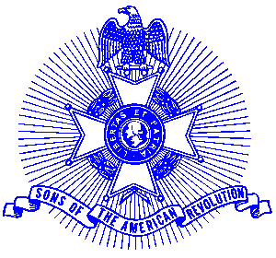Example 12 Genealogy Workshop

For Immediate Release

Genealogy Seminar To Be Conducted

The Piedmont Chapter, Sons of the American Revolution will conduct a free Genealogy Workshop from 9 AM to 1 PM on February 1, 2003 at the Family History Center, Church of Jesus Christ, Latter Day Saints, located at the corner of Grimes Bridge Road and Norcross Street in Roswell. The workshop is open to the public and will include handouts to assist attendees to pursue family research for organizations requiring lineage documentation. Information will also be provided on genealogy available through the Georgia State Archives via their web site. Andy Phrydas, Military Records Archivist, will be available to tell you about the exciting relocation of the state archives.

Advance registration is requested. Please call Bob Sapp at 770-971-0189 or Paul Prescott at 770-360-5766 to register.

The seminar is sponsored by the award winning Piedmont Chapter, Sons of the American Revolution. The chapter meets monthly on the third Saturday at 8:00 a.m. for breakfast at the Integrity Bank, 11140 State Bridge Road, Alpharetta. Men and boys who are interested in documenting their relationship to their American Revolutionary ancestors and in joining an active group with similar interest, are encouraged to contact the Chapter Registrar, Bob Sapp at 770-971-0189.

The Piedmont Chapter serves the communities of the northern suburbs of Atlanta, including Cobb, Forsyth, Cherokee and North Fulton Counties. Activities include a variety of programs to promote the patriotic, educational and historical interests resulting from the American Revolution.

