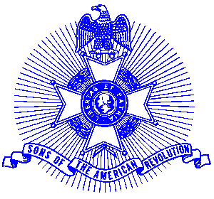Example 17 Let Freedom Ring

For Immediate Release

Let Freedom Ring July 4, 2003

The Piedmont Chapter, Sons of the American Revolution, would like to invite churches, courthouses, town halls and individuals in Cherokee, East Cobb, Forsyth, and North Fulton to participate in the annual “Let Freedom Ring” National Bell Ringing ceremony to take place on Independence Day at 2:00 pm EDT. As in the past, the program will include tolling the bell 13 times in honor of the delegates from the 13 colonies who adopted the Declaration of Independence.

This program, authorized in 1963 through a joint Resolution of Congress, is sponsored by the National Society, Sons of the American Revolution and will have nationwide participation

This year marks the 227th anniversary of the signing of the Declaration of Independence. For more information contact Americanism Chairman _____________________________

The Piedmont Chapter serves the communities of the northern suburbs of Atlanta, including Cobb, Forsyth, Cherokee and North Fulton Counties. Activities include a variety of programs to promote the patriotic, educational and historical interests resulting from the American Revolution.

Prospective members are welcome at meetings held on the third Saturday of each month at the Integrity Bank, 11140 State Bridge Road, Alpharetta. Men and boys who are interested in documenting their relationship to their American Revolutionary ancestors and in joining an active group with similar interest, are encouraged to contact the Chapter Registrar, Bob Sapp at 770-971-0189.

