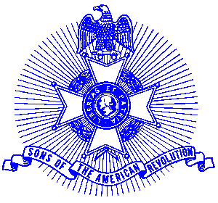Example 18 Martha Washington Award

For Immediate Release

Local Resident Wins Award

Connie Aylor of Lilburn recently was presented with a medal for her participation in programs conducted by the award winning Piedmont Chapter, Sons of the American Revolution. Connie performs in period uniform as The Continental Regiment Fife and Drum at a number of programs conducted by the Piedmont Chapter.

Connie received the Martha Washington Medal, given to a woman over 18 who provided outstanding service to the Sons of the American Revolution. The medal is gold in color and bears on the obverse a portrait of Martha Washington with Mount Vernon in the background and the inscription “SAR Martha Washington Award.” It is suspended from a chest ribbon of the SAR colors and was accompanied by an engrossed certificate.

The Piedmont Chapter serves the communities of the northern suburbs of Atlanta, including Cobb, Forsyth, Cherokee and North Fulton Counties. Activities include a variety of programs to promote the patriotic, educational and historical interests resulting from the American Revolution.

The award winning Piedmont Chapter meets monthly on the third Saturday at 8:00 a.m. for breakfast at the Integrity Bank, 11140 State Bridge Road, and Alpharetta. Men and boys who are interested in documenting their relationship to their American Revolutionary ancestors and in joining an active group with similar interest, are encouraged to contact the Chapter Registrar, Bob Sapp at 770-971-0189 or email 2rasapp@bellsouth.net.

