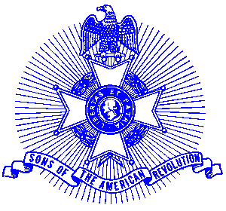Example 19 Meritorious Service

For Immediate Release

Local Resident Wins Award

Robert A. Sapp of Marietta was recently was presented by the Georgia Society, Sons of the American Revolution with a Meritorious Service Medal for his long and meritorious service to the Sons of the American Revolution. Georgia Society President Dr. Milton I. Johnson made the presentation at a recent meeting of the state society.

The medal has a silver finish and bears on the obverse a relief of Thomas Jefferson. A bar inscribed “Meritorious Service” is affixed to the breast ribbon. A certificate accompanied the presentation.

The Georgia Society consists of over 1400 members in 30 chapters located throughout Georgia. Activities include a variety of programs to promote the patriotic, educational and historical interests resulting from the American Revolution. Programs include Essay Contests for both High School students and Eagle Scouts, presentation of medals to College and High School ROTC students, Poster Contests for Elementary School students, American Revolution presentations to Elementary and Middle School students, presentation of medals to Public Safety officials, Revolutionary War Grave Dedications, Volunteer work with Veterans, presentation of Flag Certificates to deserving organizations and schools, and participation in historic battle sites observances and others.

Men and boys who are interested in documenting their relationship to their American Revolutionary ancestors and in joining an active group with similar interest, are encouraged to contact the Georgia Society at 770-952-1776 or visit web http://www.sar.org/gassar/

