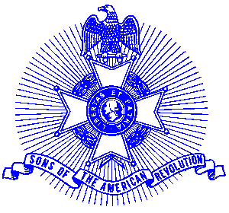Example 21 ROTC

For Immediate Release

Local Student Receives Award

Cadet Chief Petty Officer 3 Daniel M. Fowler of Powder Springs, Georgia recently received a Sons of the American Revolution JROTC medal from Colonel George Thurmond of the Piedmont Chapter at the annual McEachern High School Awards Banquet. Cadet Fowler, a 12th grade student, was selected for his high degree of merit with respect to leadership qualities, military bearing and general excellence. The Navy JROTC program at McEachern High School is commanded by Senior Instructor Commander Gene Sudol, US Navy (Ret.)

The medal is struck on a circular planchet and on the obverse is depicted a Minuteman holding a rifle, with a plow and the Liberty Bell in the background, and is inscribed with the letters, “ROTC.” The reverse is inscribed “Awarded for Leadership, Soldierly Bearing and Excellence and is suspended from a ribbon of the SAR colors. A certificate accompanied the presentation.

The purpose of the JROTC program is to develop informed and responsible citizens, strengthen character, promote an understanding of the basic elements and requirements for national security, help form self discipline, develop respect for an understanding of the need for constituted authority in a democracy and to develop an interest in the military services as a possible career.

Photo (l-r): Commander Gene Sudol, Cadet Chief Petty Officer Daniel Fowler and Colonel George Thurmond, Sons of the American Revolution.

The Piedmont Chapter meets monthly in Alpharetta and presents ROTC medals annually to 14 High School ROTC units in the North Metro Atlanta area. For information, call Bob Sapp at 770-971-0189.

