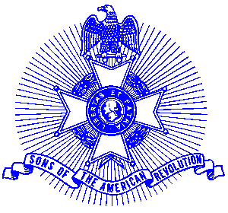Example 22 School Presentations

For Immediate Release

Summit Hill Elementary Students Receive Revolutionary War History

Fourth grade students at Summit Hill Elementary in Alpharetta recently had a unique treat to meet members of the Sons of the American Revolution who appeared in full Revolutionary War uniform. The students, studying the American Revolution, had an opportunity to hear from and ask questions of Georgia Society, Sons of the American Revolution members Jack Ferguson and George Thurmond. The American history lesson was part of a study of the Revolutionary War in the Southern States and in Georgia. Focus was on the three Georgia signers of the Declaration of Independence and that of Cesar Rodney whose image is on the Delaware state quarter.

Students Kaylor Deas, Melissa Li, and Tayna Sichynsky presented the visiting teachers with a poster, appropriately designed to depict the American Revolution.

Mrs. Sally Letchas, Fourth Grade teacher, arranged the program. Summit Hill Elementary has over 1,000 students and is under the direction of Mr. Norris Gaynor, Principal.

The Award Winning Piedmont Chapter, Sons of the American Revolution is involved in a number of programs promoting patriotic, historical and educational activities in the community. For information call 770-475-1463.
End

Photo: (l-r) front row, Kaylor Deas, Melissa Li, Tayna Sichynsky. Back row, George Thurmond, Sally Letchas.

