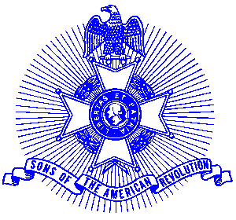Example 23 Service to Veterans

For Immediate Release

Local Residents Honored for their Service to Veterans

Six members of the award winning Piedmont Chapter, Sons of the American Revolution recently were honored with a medal presentation for their service to Veterans at the chapters’ annual George Washington Birthday dinner. Receiving the award was (l-r) COL Bob Bauchspies, COL George Thurmond, Jack Ferguson, Skip Gray, LTC Hal Dayhuff, Glynn Acree, presented by Scott Ray, President.

The award is presented for participation at Patriot Grave Site Dedications, visiting disabled veterans at the Veterans Administration Hospital, transporting veterans to and from medical appointments, visiting and rendering assistance to sick veterans at their homes, providing a morale-building environment at the Veterans Hospital such as the placement and decorations of Christmas Trees, handing out Elementary School produced Valentine Cards to bed ridden veterans, donating books, magazines, toilet articles such as the Christmas Sock Program, traveling numerous miles throughout the State of Georgia in direct support of the National Societies Veteran’s Memorial Program.

The Piedmont Chapter serves the communities of the northern suburbs of Atlanta, including Cobb, Forsyth, Cherokee and North Fulton Counties. Activities include a variety of programs to promote the patriotic, educational and historical interests resulting from the American Revolution.

The award winning Piedmont Chapter meets monthly on the third Saturday at 8:00 a.m. for breakfast at the Integrity Bank, 11140 State Bridge Road, Alpharetta. Men and boys who are interested in documenting their relationship to their American Revolutionary ancestors and in joining an active group with similar interest, are encouraged to contact the Chapter Registrar, Bob Sapp at 770-971-0189 or email 2rasapp@bellsouth.net.

