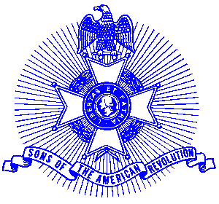Example 24 Veterans

For Immediate Release

Local Resident Wins National Award

Douglas Stansberry of Marietta, Chairman of the Piedmont Chapter, Sons of the American Revolution Veterans Committee, recently received the USS Stark Memorial Award as the outstanding chapter of the SAR for their participation in Veterans committee activities. This is the fifth consecutive year that the award has been presented to the Piedmont Chapter. Chairman Stansberry has been responsible for the chapter’s participation during this entire period.

The award, presented to Chairman Stansberry at the recent annual congress of the Sons of the American Revolution in Louisville, Kentucky, consists of a flag streamer and certificate.

Prospective members are welcome at meetings held on the third Saturday of each month at the Alpharetta Marriott Courtyard. Men and boys who are interested in documenting their relationship to their American Revolutionary ancestors and in joining an active group with similar interest, are encouraged to contact the Chapter Registrar, Bob Sapp at 770-971-0189.

