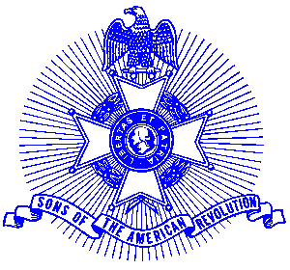Example 25 War Service

For Immediate Release

Local Resident Recognized for Korean War Service

Larry Maurer of Marietta, Chairman of the Piedmont Chapter, Sons of the American Revolution Scouting Committee, recently received a Korean War Veterans pin. Maurer, who served in the United States Navy for over 44 years, is a veteran of World War II, Korea and Viet Nam. This is the 50th anniversary of the Korean conflict.

Maurer’s work with Eagle Scouts has been commendable. He is a recipient of the “Silver Beaver Award” for his past work with Boy Scouts and his recent local essay contestant was 1st runner for the National Society, Sons of the American Revolution Eagle Scout Essay Contest winning a $4,000 scholarship.

Maurer has been a member of the Piedmont Chapter since 1997. The chapter serves the communities of the northern suburbs of Atlanta, including Cobb, Forsyth, Cherokee and North Fulton Counties. Activities include a variety of programs to promote the patriotic, educational and historical interests resulting from the American Revolution.

Prospective members are welcome at meetings held on the third Saturday of each month at the Alpharetta Marriott Courtyard. Men and boys who are interested in documenting their relationship to their American Revolutionary ancestors and in joining an active group with similar interest, are encouraged to contact the Chapter Registrar, Bob Sapp at 770-971-0189.

