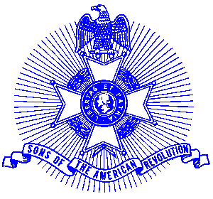Example 40 GASSAR President

For Immediate Release

Local Resident Elected President of State Society

Norcross resident Brigadier General (Retired) John W. Gillette was recently installed as the President of the Georgia Society, Sons of the American Revolution at the annual meeting of the society in Macon, Georgia. The organization has over 1400 members and 30 chapters throughout the state. The Georgia Society is recognized as one of the leading Societies in the countrywide with membership of over 27,000.

General Gillette attended Wittenberg University, Springfield, Ohio and performed graduate study at Princeton University. He is a 1966 graduate of the Army’s Command and General Staff College, Fort Leavenworth, Kansas and the Army War College, Carlisle Barracks, Pennsylvania.

General Gillette served in combat as a private in the infantry during World War II, receiving a Combat Infantryman Badge and a Bronze Star for his service in the 104th “Timberwolf” Infantry Division.

General Gillette was commissioned as an officer in 1948 and served in a number of assignments of increased responsibilities. In July 1976 Governor George Busbee appointed him as Assistant Adjutant General of the Georgia National Guard. Upon retirement in 1983, General Gillette received the Legion of Merit for distinguished service. In 1984 the Adjutant General tasked him to form the Georgia State Guard (later renamed the Georgia State Defense Force) which he commander until retirement from State duty in 1993.

General Gillette is a member of a number of heritage and military organizations and the Atlanta Chapter, Sons of the American Revolution. He previously served the Georgia Society as Senior Vice President.

The Georgia Society consists of over 1400 members in 30 chapters located throughout Georgia. Activities include a variety of programs to promote the patriotic, educational and historical interests resulting from the American Revolution. Programs include Essay Contests for both High School students and Eagle Scouts, presentation of medals to College and High School ROTC students, Poster Contests for Elementary School students, American Revolution presentations to Elementary and Middle School students, presentation of medals to Public Safety officials, Revolutionary War Grave Dedications, Volunteer work with Veterans, presentation of Flag Certificates to deserving organizations and schools, and participation in historic battle sites observances and others.

Men or boys who are interested in documenting their relationship to their American Revolutionary ancestors and in joining an active group with similar interest, are encouraged to contact the Georgia Society at 770-952-1776 or visit web site http://www.sar.org/gassar/

