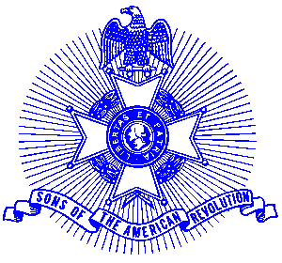Example 35 Minuteman Award

For Immediate Release

Local Resident Receives National Award

Dr. T. Fisher Craft was recently honored at the 113th Annual Congress of the National Society Sons of the American Revolution by being presented with the Minuteman award. The award is the most prestigious award of the National Society.

The award, established in 1951, is presented only to those Compatriots who have made distinguished and exceptional contributions of service to the National Society. This is the highest award of the national Society and the honored Compatriot may receive it only once.

The medal is of sterling silver. It depicts a Minuteman holding a rifle with a plow and the Liberty Bell in the background. The medal is suspended from a neck ribbon of light blue silk.

The Georgia Society consists of over 1400 members in 30 chapters located throughout Georgia. Activities include a variety of programs to promote the patriotic, educational and historical interests resulting from the American Revolution. Programs include Essay Contests for both High School students and Eagle Scouts, presentation of medals to College and High School ROTC students, Poster Contests for Elementary School students, American Revolution presentations to Elementary and Middle School students, presentation of medals to Public Safety officials, Revolutionary War Grave Dedications, Volunteer work with Veterans, presentation of Flag Certificates to deserving organizations and schools, and participation in historic battle sites observances and others.

Men and boys who are interested in documenting their relationship to their American Revolutionary ancestors and in joining an active group with similar interest, are encouraged to contact the Georgia Society at 770-952-1776 or visit web site http://www.sar.org/gassar/

