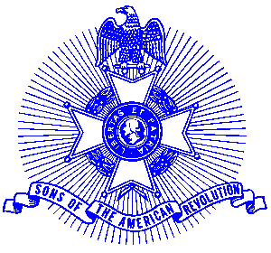Example 36 Patriot Medal

For Immediate Release

Local Resident Receives Award

H. Ross Arnold of Atlanta recently received the Patriot Medal, the highest award given by the Georgia Society Sons of the American Revolution. Compatriot President General James R. Westlake presented the award at the annual meeting of the Georgia Society in Macon.

The Patriot medal is presented for long, faithful and outstanding service to the state society. The medal is sterling silver and bears the portrait of Compatriot General of the Army Douglas MacArthur on the obverse within the inscription, “The National Society of the Sons of the American Revolution.” The medal is suspended from a chest ribbon of royal blue color. The design of the medal was selected by Compatriot MacArthur himself. He received the first medal, presented posthumously at his tomb in Norfolk, Virginia on October 19, 1964 where it is on permanent display. The medal was accompanied with a special certificate for Compatriot Arnold.

The Georgia Society consists of over 1400 members in 30 chapters located throughout Georgia. Activities include a variety of programs to promote the patriotic, educational and historical interests resulting from the American Revolution. Programs include Essay Contests for both High School students and Eagle Scouts, presentation of medals to College and High School ROTC students, Poster Contests for Elementary School students, American Revolution presentations to Elementary and Middle School students, presentation of medals to Public Safety officials, Revolutionary War Grave Dedications, Volunteer work with Veterans, presentation of Flag Certificates to deserving organizations and schools, and participation in historic battle sites observances and others.

Men and boys who are interested in documenting their relationship to their American Revolutionary ancestors and in joining an active group with similar interest, are encouraged to contact the Georgia Society at 770-952-1776 or visit web http://www.sar.org/gassar/

