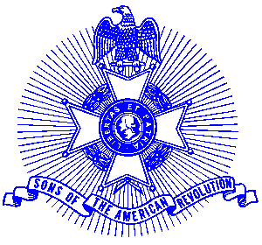Example 38 GASSAR Secretary

For Immediate Release

Local Resident Installed as Secretary of State Society

Cleveland resident Kline O. Pugh. was recently installed as Secretary of the Georgia Society, Sons of the American Revolution at the organizations’ Annual Meeting held in Macon. President General B. Rice Aston of the National Society conducted the installation. This is the sixth term Compatriot Pugh has served as Secretary of the Georgia Society.

The Georgia Society has 30 chapters around the state and over 1,400 members. Nationally, the organization boasts over 27,000 members with headquarters in Louisville, Kentucky.

Compatriot Pugh has served as Past President of the Joseph Habersham Chapter that meets in Cornelia and Clarkesville.

The Georgia Society consists of over 1400 members in 30 chapters located throughout Georgia. Activities include a variety of programs to promote the patriotic, educational and historical interests resulting from the American Revolution. Programs include Essay Contests for both High School students and Eagle Scouts, presentation of medals to College and High School ROTC students, Poster Contests for Elementary School students, American Revolution presentations to Elementary and Middle School students, presentation of medals to Public Safety officials, Revolutionary War Grave Dedications, Volunteer work with Veterans, presentation of Flag Certificates to deserving organizations and schools, and participation in historic battle sites observances and others.

Men and boys who are interested in documenting their relationship to their American Revolutionary ancestors and in joining an active group with similar interest, are encouraged to contact the Georgia Society at 770-952-1776 or visit web site http://www.sar.org/gassar/

