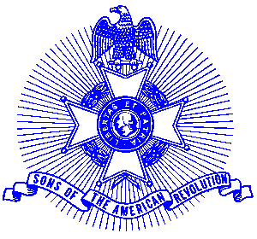Example 27 SAR Medal of Appreciation

For Immediate Release

Local Resident Receives Award

Connie Allgood of Alpharetta recently was presented an SAR Medal of Appreciation in recognition of her outstanding services rendered to the award winning Piedmont Chapter, Sons of the American Revolution. Connie, a member of the William Sewell DAR Chapter, assisted the Piedmont Chapter in recruiting three new members for the SAR.

Connie received the medal at the monthly meeting of her DAR Chapter by Piedmont Chapter President Glynn Acree. The medal is gold in color and bears on the obverse a relief of Molly Pitcher and is inscribed, “Medal of Appreciation.” It is suspended from a chest ribbon of the SAR colors and was accompanied by an engrossed certificate.

The Piedmont Chapter serves the communities of the northern suburbs of Atlanta, including Cobb, Forsyth, Cherokee and North Fulton Counties. Activities include a variety of programs to promote the patriotic, educational and historical interests resulting from the American Revolution.

The award winning Piedmont Chapter meets monthly on the third Saturday at 8:00 a.m. for breakfast at the Integrity Bank, 11140 State Bridge Road, and Alpharetta. Men and boys who are interested in documenting their relationship to their American Revolutionary ancestors and in joining an active group with similar interest, are encouraged to contact the Chapter Registrar, Bob Sapp at 770-971-0189 or email 2rasapp@bellsouth.net.

