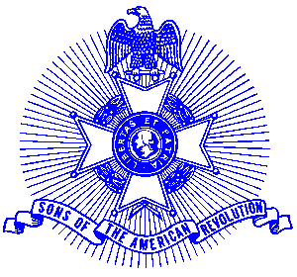Example 26 Patriots Day Proclamation

Sons of the American Revolution Promotes Observance of Patriots Day

Georgia Governor Sonny Perdue recently presented a Patriots Day Proclamation to the Piedmont Chapter, Sons of the American Revolution. Patriots Day is celebrated April 19th each year and the Piedmont Chapter is promoting a state-wide observance by every household and business to remember “the shot heard around the world.” The proclamation reads as follows:

By the Governor of the State of Georgia
A Proclamation
Patriots Day

Whereas: April 19th, marks the date in 1775 when the towns of Lexington and Concord, Massachusetts were marched upon by the British regulars in an effort to confiscate munitions of local militia, and;

Whereas: The results was the “shot heard around the world” and the rout of the Redcoats, and;

Whereas: Patriots Day serves to remind citizens of our Revolution and the sacrifices endured during the eight years of struggle for American independence, and;

Whereas: The descendants of the soldiers who fought in the American Revolution encourages the community to proclaim April 19th of each year as Patriots Day in commemoration of the War of the American Revolution and the struggle for independence, now;

Therefore; I, Sonny Perdue, Governor of the state of Georgia do hereby proclaim the date of April 19, 2003 as

Patriots Day.

And urge all Georgians to become more knowledgeable of the role the Revolution played in the history of our great nation.

In witness thereof, I have herrinto set my hand and cause the seal of the Executive Department to be affixed this 15th day of April in the year of our Lord two thousand three.

Signed: Sonny Perdue

Participants in the ceremony include Piedmont members (l-r) Glynn Acree, President; Skip Gray; Billy Templeton; Governor Sonny Perdue; Bob Buck; Ken Howell and George Thurmond.

