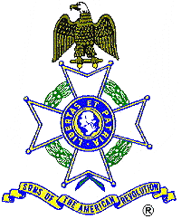
For Immediate Release

Local Resident Receives Award

Woodstock Resident Nancy Prescott recently received the Camp Followers Award from the Georgia Society, Sons of the American Revolution. Society President George Wheeless presented Mrs. Prescott with the award at the Society’s annual meeting in Athens.

The award consists of a pin that contains the image of a “Minuteman,” with his musket in hand ready to defend his country. In the background is his plowshare. The pin is encircled with the inscription “Sons of the American Revolution Outstanding Citizenship Award.” The award also comes with a certificate and is presented to the spouses of those in the Color Guard who accompany their husbands in state and national events over a three year period. The Color Guard is some 69 members strong and appears in a number of local, state and national events annually.

The Georgia Society consists of over 1200 members in 30 chapters located throughout Georgia. Activities include a variety of programs to promote the patriotic, educational and historical interests resulting from the American Revolution. Programs include Essay Contests for both High School students and Eagle Scouts, presentation of medals to College and High School ROTC students, Poster Contests for Elementary School students, American Revolution presentations to Elementary and Middle School students, presentation of medals to Public Safety officials, Revolutionary War Grave Dedications, Volunteer work with Veterans, presentation of Flag Certificates to deserving organizations and schools, and participation in historic battle sites observances and others. For information, contact Bob Sapp, Genealogist at 770-971-0189.

