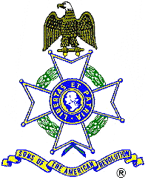26.00.4H Pre Media Release

For Immediate Release

American Revolution Patriot to be Remembered

At 11:00 A.M., Saturday, March 29, 2008, the Sons of the American Revolution will host a ceremony honoring Revolutionary War veteran Jeremiah Lumsden by installing a memorial marker at his grave in Jasper County, Georgia.

The ceremony, featuring a presentation of colors by the SAR State Color Guard, a Fife and Drum duo, a Bagpiper, and a Musketeer (all dressed in Revolutionary War period uniforms), will be held in the Kelly Family Cemetery near Shady Dale, Georgia..

A family descendant and SAR member Lieutenant Colonel Donald Gunn, U.S. Army, will present the biography of his ancestor. The public is invited to see this colorful and dignified tribute to one of America’s first veterans.

Directions: North of Shady Dale on highway142 Begin looking for Barr Bridge Road on the left and after passing Kline Road (on the left) look for distinctive flags on the right for access to the cemetery.

The Sons of the American Revolution and Daughters of the American Revolution are national patriotic, historical and educational societies whose members are direct descendents of the patriots who earned our independence. For additional information or directions contact George Thurmond at 770-475-1463.

