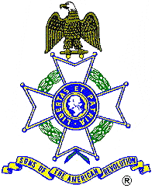

For Immediate Release

American Revolution Patriot to be Remembered

At 11:00 A.M., Saturday, May 5, the Sons and Daughters of the American Revolution will host a ceremony honoring the grave of Revolutionary War veteran Jordan Holcombe.

The ceremony, featuring a presentation of colors by the SAR State Color Guard, a Fife and Drum duo, a Bagpiper, and a Musketeer (all dressed in Revolutionary War period uniforms), will be held in the Alta Vista Cemetery in Gainesville.

A family descendant, DAR member Lynn Briggs will present the biography of her ancestor in addition to a representative of the Mayor’s Office. The public is invited to see this colorful and dignified tribute to one of America’s first Veterans.

The Sons of the American Revolution and Daughters of the American Revolution are national patriotic, historical and educational societies whose members are direct descendents of the patriots who earned our independence. For additional information contact George Thurmond at 770-475-1463.

