The award winning Piedmont Chapter, Sons of the American Revolution meets monthly on the third Saturday at 8:00 a.m. for breakfast at the Integrity Bank, 11140 State Bridge Road, Alpharetta. Men and boys who are interested in documenting their relationship to their American Revolutionary ancestors and in joining an active group with similar interest, are encouraged to contact the Chapter Registrar, Bob Sapp at 770-971-0189.

The Piedmont Chapter serves the communities of the northern suburbs of Atlanta, including Cobb, Forsyth, Cherokee and North Fulton Counties. Activities include a variety of programs to promote the patriotic, educational and historical interests resulting from the American Revolution.

For membership information
Contact
Bob Sapp, Registrar
770-971-0189
email: 2rasapp@bellsouth.net

This brochure funded by Integrity Bank

Return to Table of Contents

The Story of the

Purple Heart

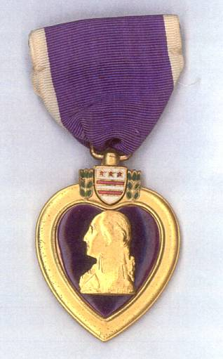

Compliments of the award winning

Piedmont Chapter

Sons of the American Revolution

11140 State Bridge Road

Alpharetta, Georgia 30022
The Military Badge of Merit

Does this look familiar? General George Washington, “ever desirous to cherish a virtuous ambition in his soldiers,” established the Badge of Military Merit on August 7, 1782. He directed that it be “the figure of a heart in purple cloth, or silk, edged with narrow lace or binding.” Although Washington intended this forerunner of today’s Purple Heart to be bestowed “whenever any singular meritorious action is performed,” only three soldiers of the American Revolution were awarded this badge.

Sergeant Elijah Churchill, 2nd Regiment, Light Dragoons, was awarded the badge for his part in two successful raids behind British lines. In November 1780, leading only 16 men, he was able to capture and destroy the heavily manned British fortifications at Corum, New York. Not only did they burn 300 tons of hay, but they also burned a British supply schooner and captured 50 prisoners. In accomplishing this, only one of his men was wounded. The second raid was on Ft Slongo in October 1781. Churchill’s unit, without the loss of a single man, captured and destroyed the fort in less than 24 hours.

The badge was awarded to Sergeant William Brown, 5th Connecticut Regiment, for leading an advance party who, using only bayonets, penetrated the British fortifications at Yorktown, Virginia on October 14, 1781. Although challenged by enemy gunfire and grenades, Brown’s party drove the British from their position in only 125 minutes.

The third and last badge was given to Sergeant Daniel Bissell, 2nd Connecticut Regiment, for masquerading as a British soldier from August 1781 to September 1782. The information he gathered helped prepare for the American-French attack on the city of New York.

With the American Revolution over and the army disbanded, the Badge of Military Merit seemingly passed into history until February 22, 1932, the 200th anniversary of Washington’s birth. On that date General Douglas MacArthur, then War Department Chief of Staff, announced the restoration of the Purple Heart for use by the U.S. Army. Elizabeth Will of the Office of the Quartermaster General is credited with the 1932 design. The modern medal is reminiscent of Washington’s Badge of Merit with its heart shape, however, it now contains a likeness of Washington and his family coat of arms.

Over the years, Presidents Franklin Roosevelt, Harry Truman and John Kennedy established uniform standards and extended eligibility for the award. Today, the medal can only be given to military or civilian nationals, serving with one of the U. S. Armed Forces since April 5, 1917, that have been wounded or killed under a specific set of circumstances. Although the criteria for the award is very different than that set by General Washington, it still honors those who have demonstrated “unusual gallantry” and “extraordinary fidelity.
Recipients of the Purple Heart today receive a certificate that reads:

The United States of America
To All Who Shall See These Presents, Greeting:
This is to certify that
The President of the United States of America
Has Awarded The

PURPLE HEART

Established by General George Washington
At Newberg, New York, August 7, 1782

To

For Wounds Received
In Action
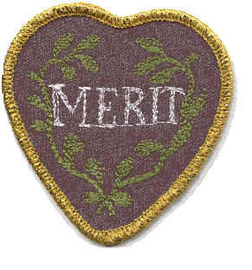

Return to Table of Contents

