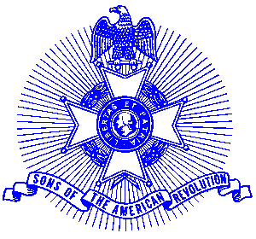

Date:

Business
Address
City

Dear;

The Piedmont Chapter of the National Society of the Sons of the American Revolution sponsors several contests in schools of Cobb, Cherokee, Fulton, Forsyth and Gwinnett Counties. These contests are built around increasing the student awareness in American heritage and patriotism. The contests have national oversight in that contestants have opportunities to win at local, state and national levels.

The enclosed Partnership Invitation is submitted for your consideration in providing a grant to assist the Piedmont Chapter in providing award incentives to contest applicants. The Piedmont Chapter will provide the administrative actions in conducting the contests and provide an accounting of awards given.

The National Society of the Sons of the American Revolution is a federal tax-exempt organization and donations are tax exempt under section 501(c) (3) of the Internal Revenue Code. The national Society’s Federal Number is 53-0116355 and the Piedmont Chapter EIN is 31-1425020.

Thank you for considering a partnership agreement in encouraging our students to look at the heritage we have as Americans and the freedoms granted with American citizenship.

I will be contacting you shortly to seek your assistance in the important program.

Sincerely,

Cc: Partnership Invitation

