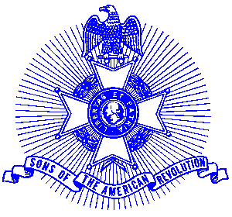May 3, 2005

Chapter Presidents
Regional Vice Presidents

Let Freedom Ring

In 1963, Congress passed a Joint Resolution asking that bells be rung 13 times at 2:00 p.m. EDST on July 4th in honor of the signing of the Declaration of Independence. Since 1969 the Pennsylvania Society of Sons of the Revolution has conducted a major ceremony at Independence Hall and the Liberty Bell Center, which highlights children who are direct descendants of the Signers. The participants gently tap the Liberty Bell 13 times as the signal for bells allover the country to join in. There are literally thousands of bell locations around the country taking part, including all the ships of the U.S. Navy, Coast Guard, and the Merchant Marines. Let Freedom Ring is now the largest national event associated with the American Revolution.

The National Society Sons of the American Revolution encourages all chapters to participate in the Let Freedom Ring Program. This program will be part of the Memorial Service at the NSSAR Congress in Louisville this coming Ju1y 4th.

Please encourage your membership to recruit bell-ringing locations to take part in Let Freedom Ring 2005. You are also encouraged to establish joint ceremonies in your area -perhaps in cooperation with other organizations such as the Veterans of Foreign Wars, DAR, CAR, the Masons, American Legion, local National Guard units, fire departments and police departments. Nearly every municipality has an Independence Day ceremony. Why not ask them to include a Let Freedom Ring 2005 ceremony in it? Refer to Source Book 16.17.17 for a sample Let Freedom Ring media release.

To learn more about Let Freedom Ring by visit website, www.let-freedom-ring.org or call Let Freedom Ring at 800-330-1776.

Please include your chapter Let Freedom Ring 2005 activity in our July 23 Board of Managers Report.

Yours in Patriotism,

George Thurmond

Cc: Executive Committee
Billy Thompson, Americanism Committee Chairman

“Get Excited about the SAR!”

